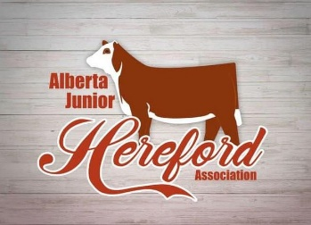

Alberta Junior Hereford Association
34071 Range Road 21
Red Deer County, AB T0M 0K0
403-586-0602
wesvanessa@hotmail.com

To Whom This May Concern:

The Alberta Junior Hereford Association is planning their upcoming
summer show from June 28-30th, 2024. We are hoping to attract as many
junior cattlemen enthusiasts as possible this year, and we need your help!

The AJHA holds a summer cattle show for kids at different
places throughout Alberta, and this year we hope to expand our program.
We have the July long weekend filled with activities. We have decided to
emphasize that we are a family-friendly show and encourage parents to
help when needed. Thank you to all supporters of our shows in the past; we
greatly appreciate your support.

We are looking for donations this year to help offset our costs. We have
listed the sponsorship levels below this letter; please read through the benefits
to each category. Supporting our kids in these types of programs where the
kids learn more about their livestock, meet other kids, and gain confidence in
the agriculture industry is priceless.

We realize that you receive many requests for donations and that your
budget is limited. The Alberta Junior Hereford Association thanks you in
advance for your consideration. Also, please take this as your invitation to
attend and participate in our show “Red, White & True Classic.” Hope to see
you there!

Sincerely,
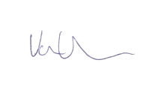
Vanessa Van Sickle
Alberta Junior Hereford Association, Adult Advisor

Sponsorship Levels:
Bronze (up to $200.00)
- Name printed in weekend program
- Name announced during the AJHA cattle show
- Instagram story through the AJHA social media
- Thank you to all sponsors in the AJHA Facebook group

Silver (up to $300.00)
- Business card size ad in weekend program
- Name announced during the AJHA cattle show
- Instagram story through the AJHA social media
- Thank you to all sponsors in the AJHA Facebook group

Gold (up to $500.00)
- Half page ad in weekend program
- Name announced during the AJHA cattle show
- Business sign hung in show ring
- Instagram post &amp; story through the AJHA social media
- Thank you to all sponsors in the AJHA Facebook group

Platinum (up to $1200)
- Full page ad in weekend program
- Name announced during the AJHA cattle show
- Business sign hung in show ring
- Instagram post &amp; story through the AJHA social media
- Thank you to all sponsors in the AJHA Facebook group

Diamond ($1200+)
-Full page ad in weekend program
- Name announced during the AJHA cattle show
- Business sign hung in show ring
- Instagram post &amp; story through the AJHA social media
- Thank you to all sponsors in the AJHA Facebook group
-Logo or name on AJHA show apparel
-4 Supper tickets for Saturday

